Valgrind:

Valgrind is a programming tool for memory debugging, memory leak detection, and profiling. Valgrind was originally designed to be a free memory debugging tool for Linux. Valgrind can help us speed up our programs. In automatic testing. By using Valgrind tools in your automatic unit, integration, system, or regression test, you can be confident no code will be unchecked.

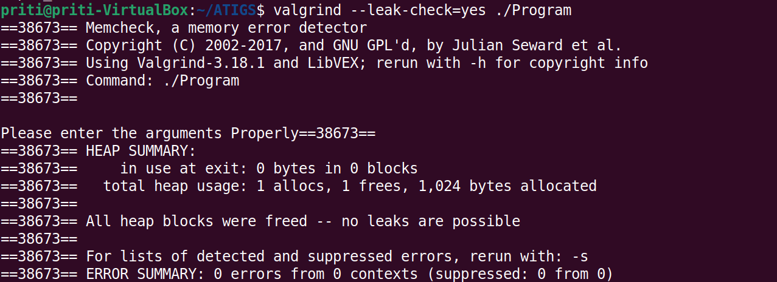

valgrind report in ATIGS